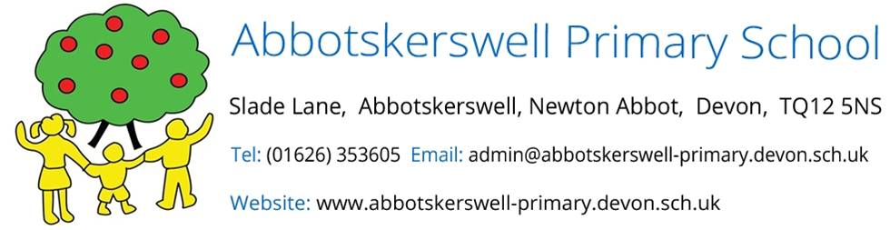

27th September 2021
On behalf of the governing board, I would like to thank all our parents, carers and children for being so supportive to the school in what has been yet another trying year for everyone.

It's sometimes meant that there have been experiences that our children couldn't do, however there have also been many wonderful things that have gone ahead such as learning new skills in the forest school, making music with our resident pop-star James Kirby, creating stunning Murals with a visiting artist, learning first aid and participating in the gloriously sunny sports day.

We are so proud of how our children have adapted and got on with all the changes. I know you will join us in thanking all the staff at the school who have been absolutely amazing in ensuring that school life carries on with some semblance of normality.

We particularly want to thank Mr Martin for leading the school through these rocky times with a cool, calm head and getting the balance between safety and improving children's outcomes just right. The improvements to the physical school learning environment this year have been so impressive, and it has been great to see these fantastic new spaces being used by all children to support their learning.

The governors would also like to thank the PTFA for continuing to raise money for the school during these difficult times. Their determination and hard work are very much appreciated.

There are so many to thank but finally, I would like to extend my appreciation all the members of the Governing Board who have volunteered their time to support and challenge the school. Sadly, we have to say goodbye to Louise Walker who is going on to pastures new. Louise has been a brilliant safeguarding governor over the years and has brought her invaluable knowledge and experience to an incredibly important role.

Jenny Hersey
Chair of Governors
Abbotskerswell Primary School

